Screen shots of all of forms

Main Menu:
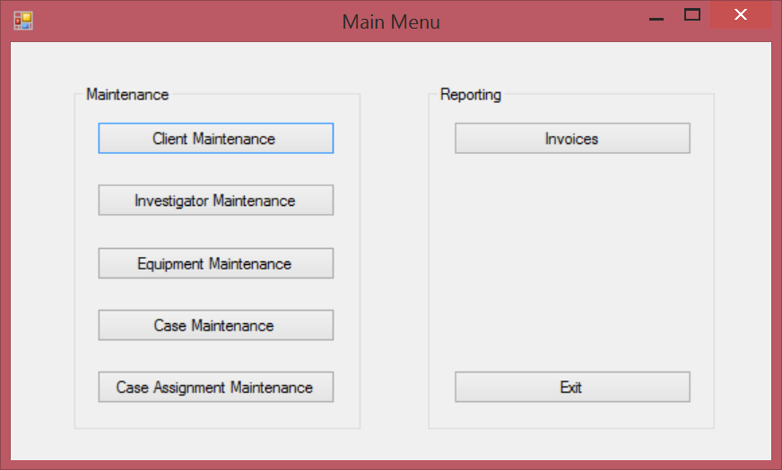
Client Form:
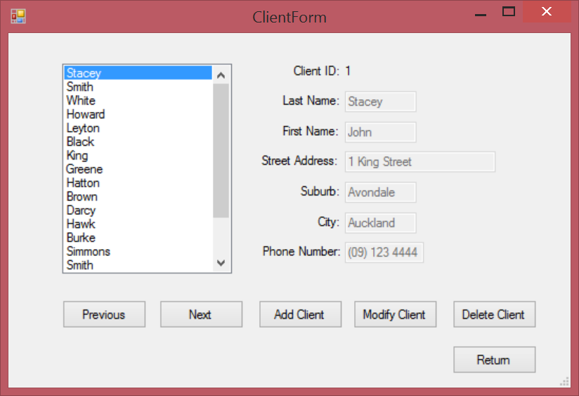
Client Form – Add Client:
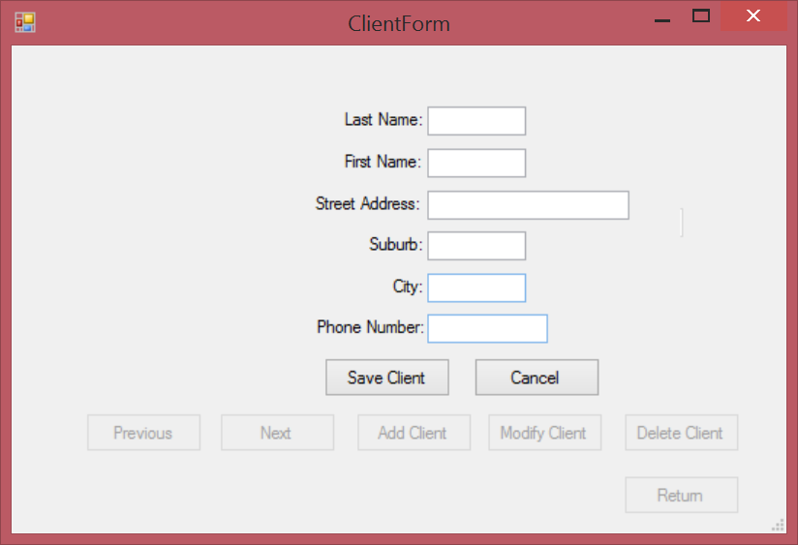
Client Form – Modify Client:
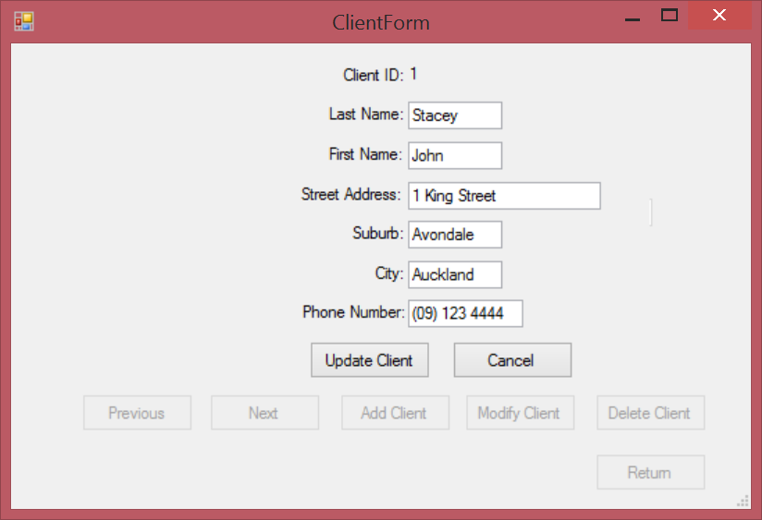

Client Form – Delete Client who have a case:
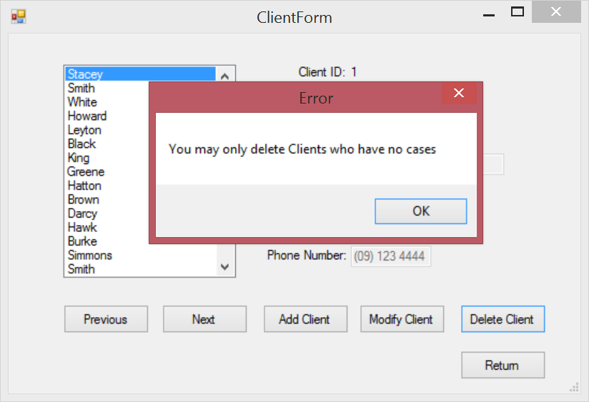
Client Form – Delete Client who have no cases:
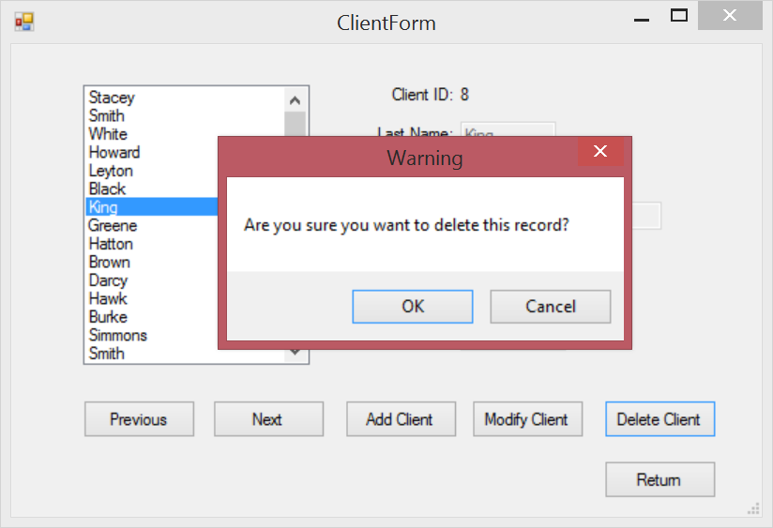

Investigator Form:
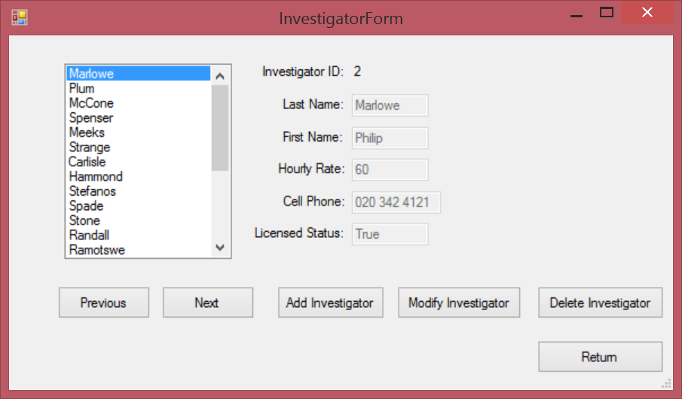
Investigator Form – Add Investigator:
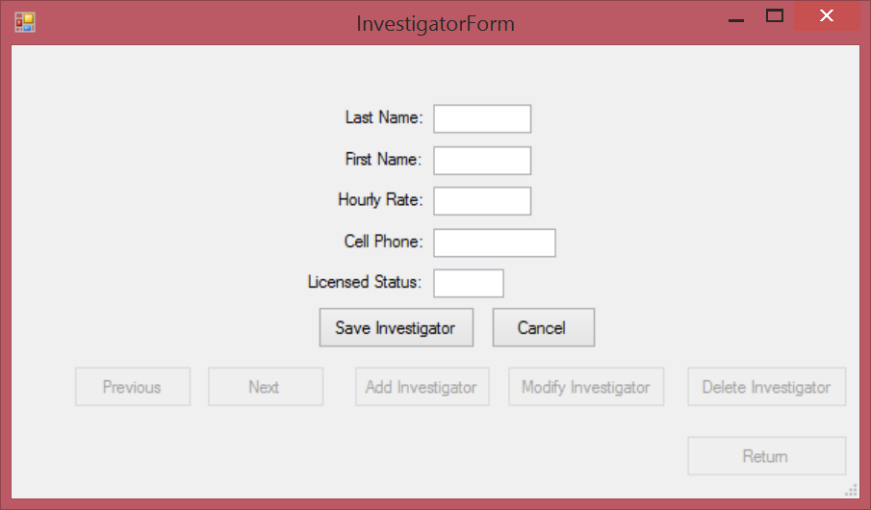

Investigator Form – Modify Investigator:
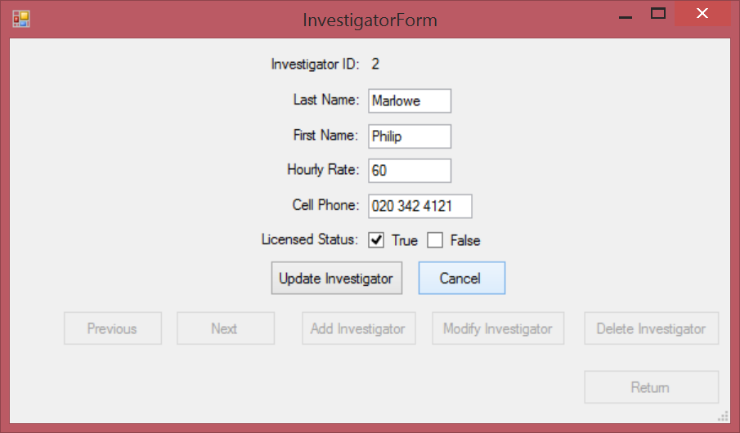
Investigator Form – Delete Investigators who are assigned to assignments:
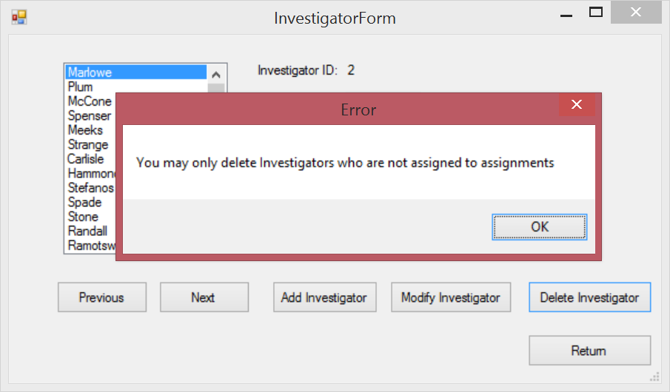

Investigator Form – Delete Investigator:
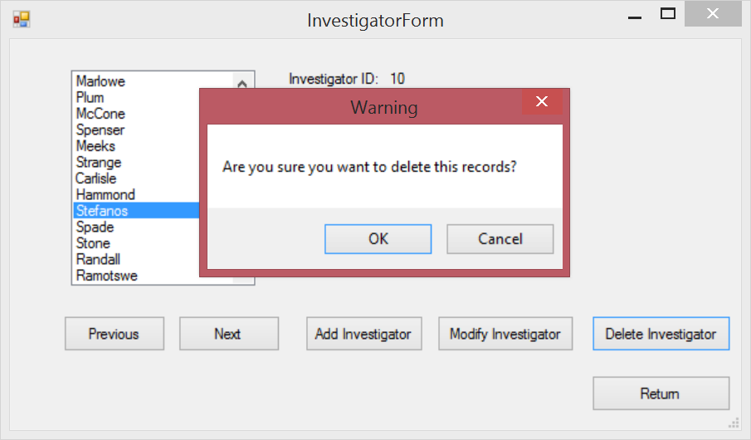
Investigator Form – Delete Investigators who are not allocated equipment:
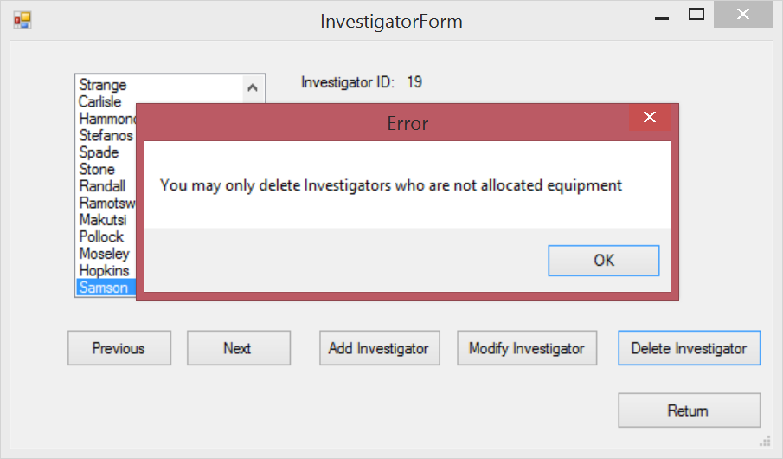

Equipment Form:
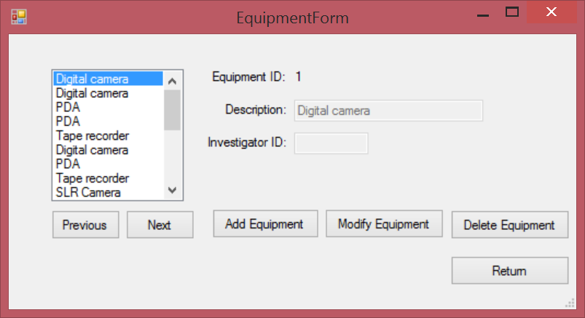
Equipment Form – Add Equipment:
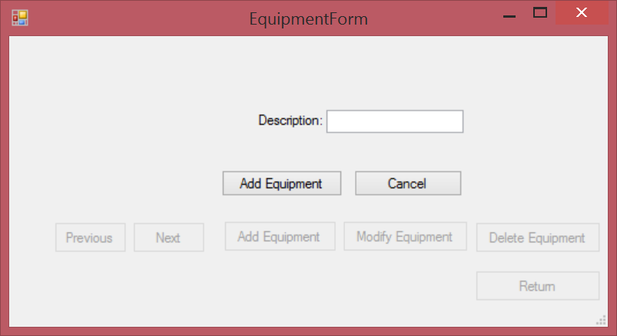

Equipment Form – Modify Equipment:
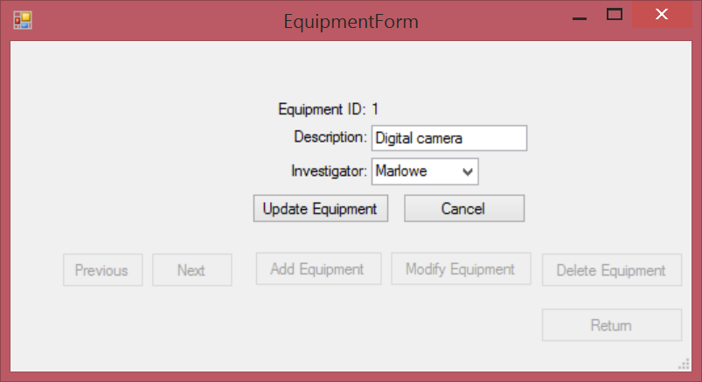
Equipment Form – Delete Equipment:
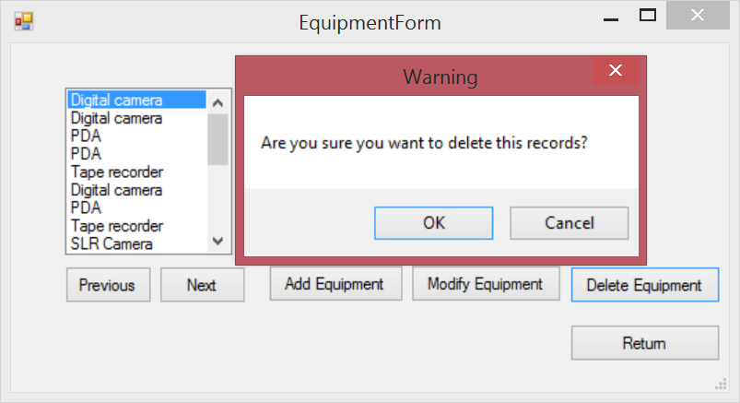

Equipment Form – Delete Equipment that is assigned to an investigator:
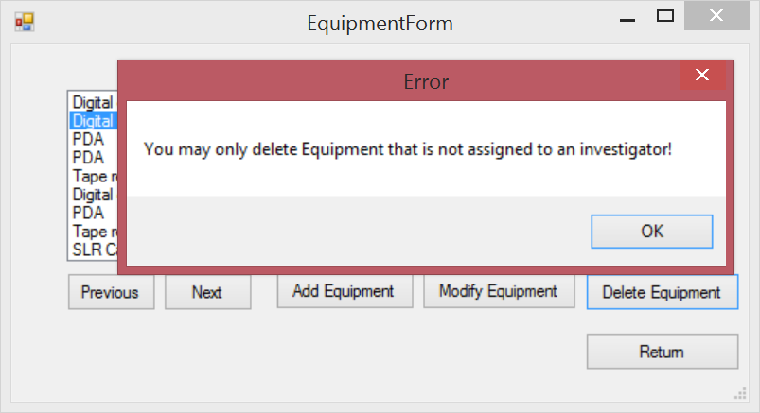

Case Form:
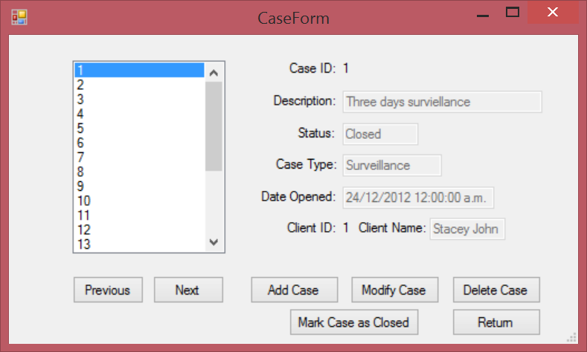

Case Form – Add Case:
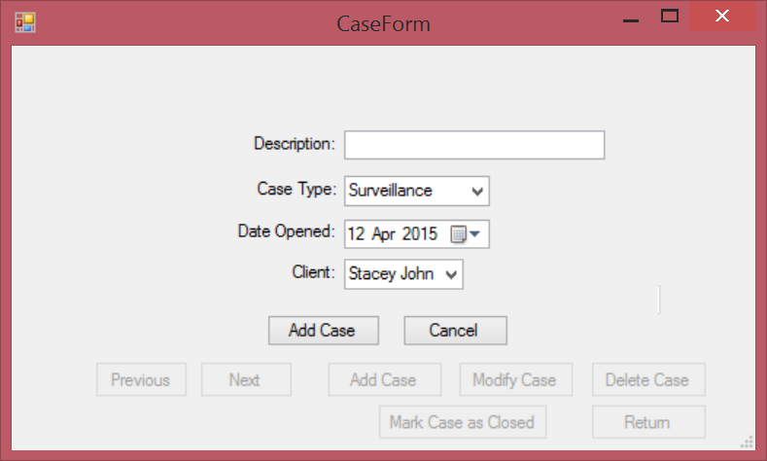
Case Form – Modify Case which status is Closed:
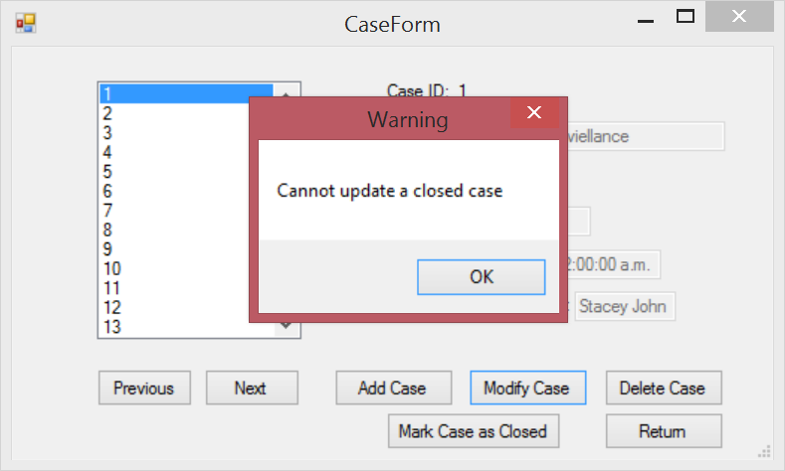

Case Form – Modify Case which status is Open:
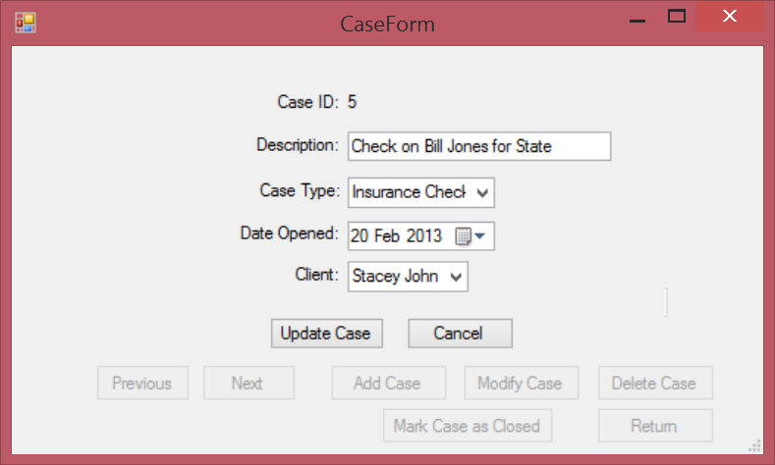
Case Form – Delete Case which status is Open:
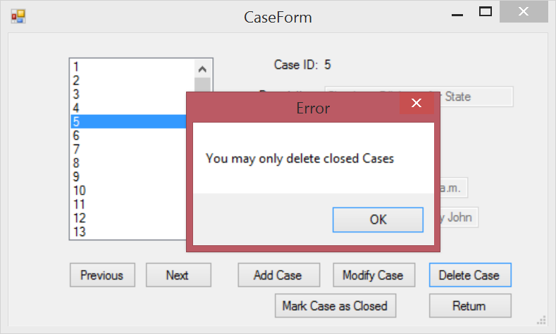

Case Form – Delete Case:
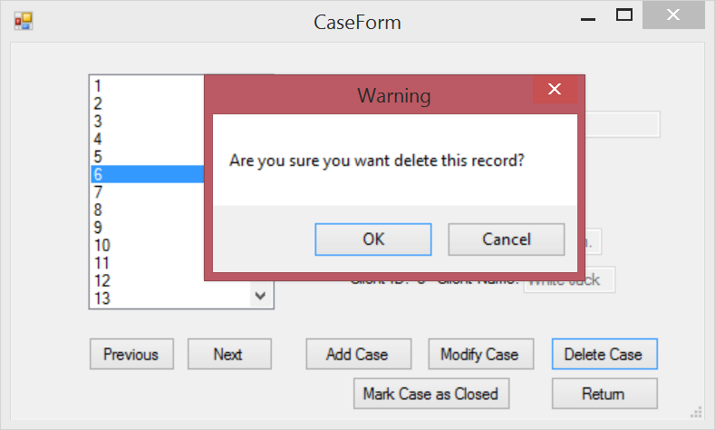
Case Form – Mark Case as Closed:
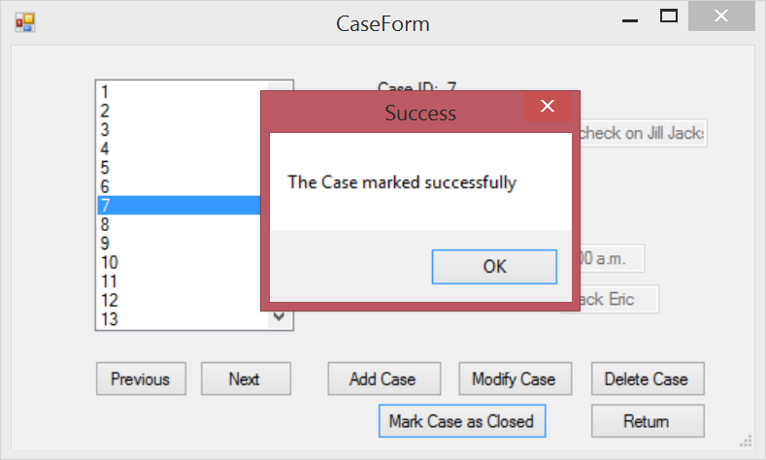

Case Assignment Form:
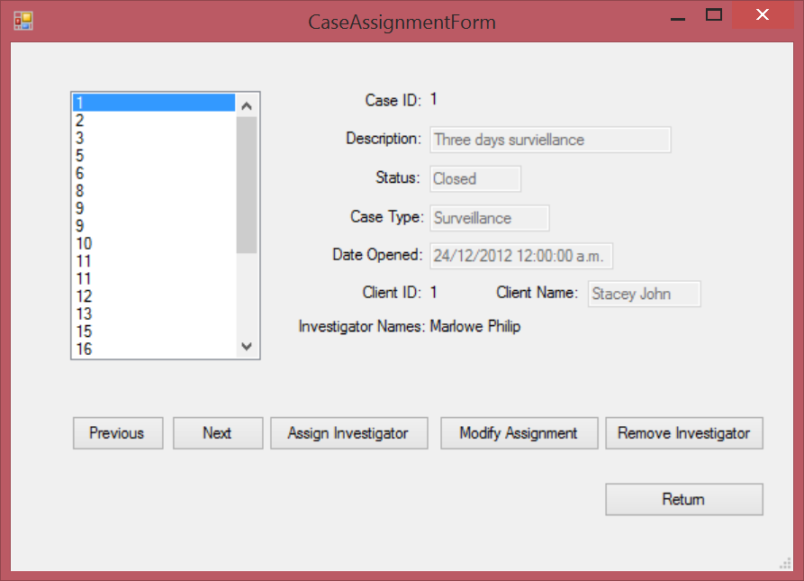
Case Assignment Form – Assign Investigator that Case status is Closed:
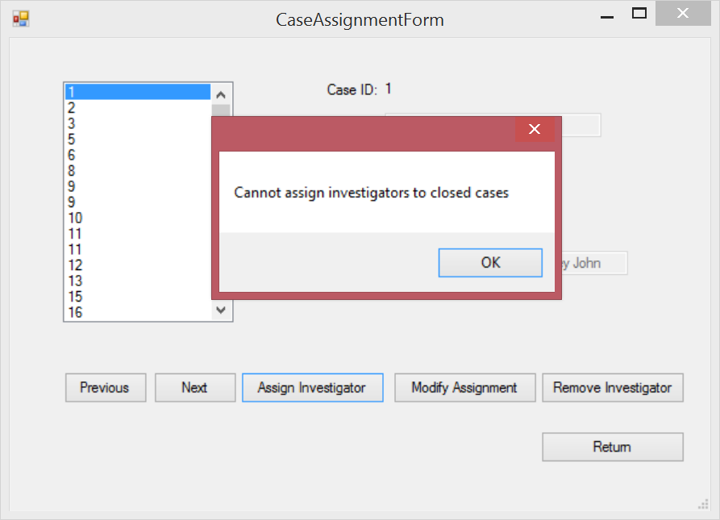

Case Assignment Form – Assign Investigator:
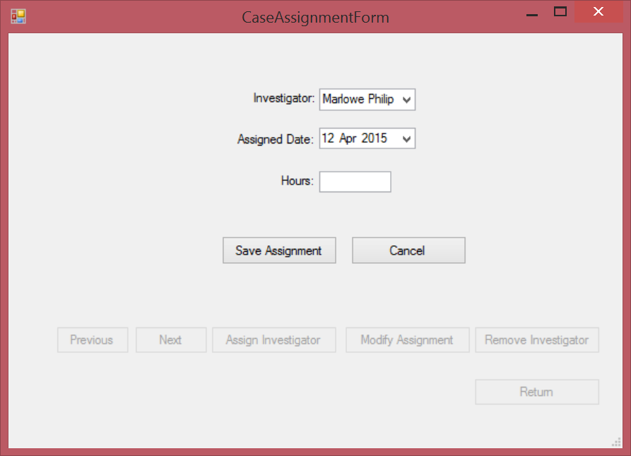
Case Assignment Form – Modify Assignment:
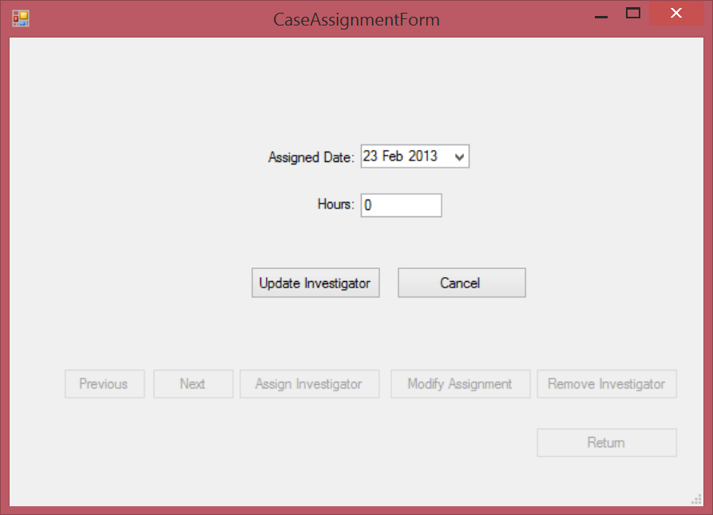

Case Assignment Form – Remove Investigator:
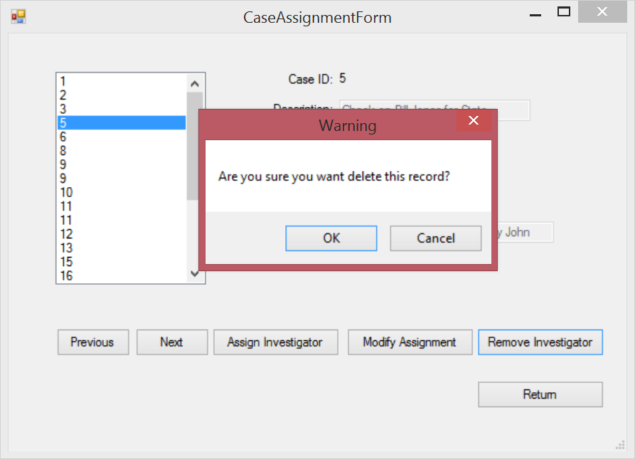
Case Assignment Form – Remove Investigator that Cases stauts is Closed:
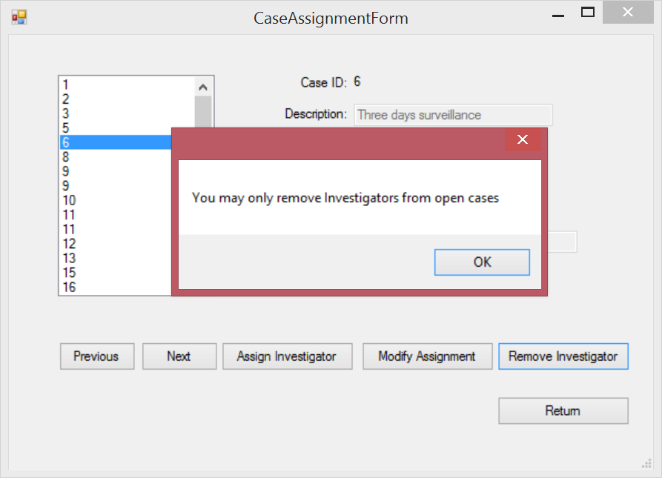

Invoices Form:
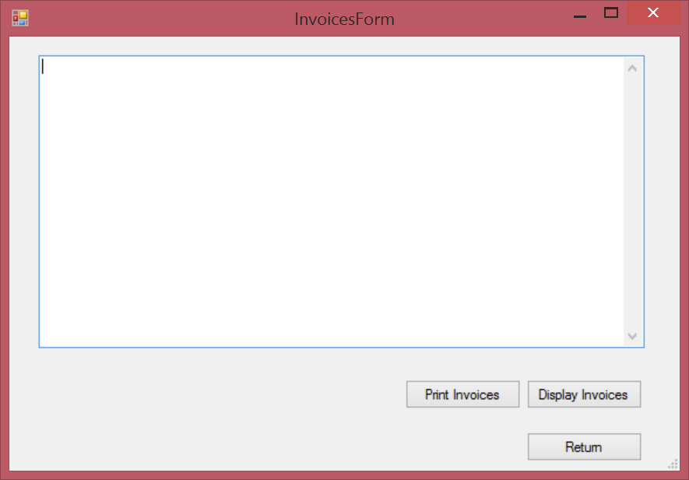
Invoices Form – Display Invoices:
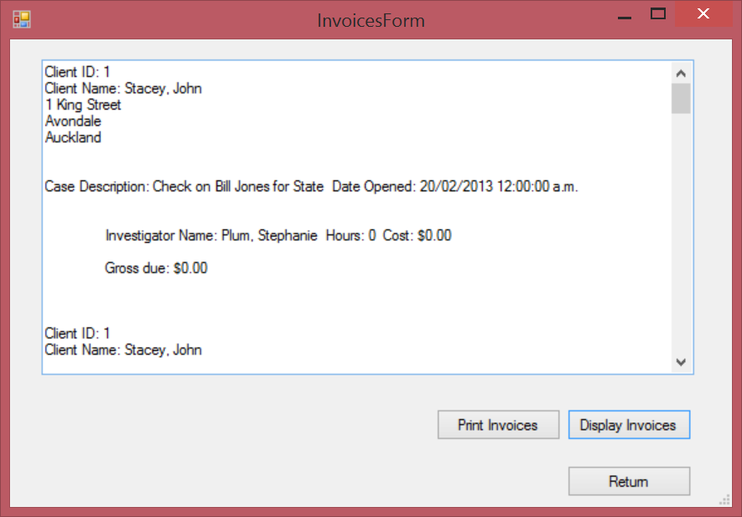
Invoices Form – Print Invoices:
